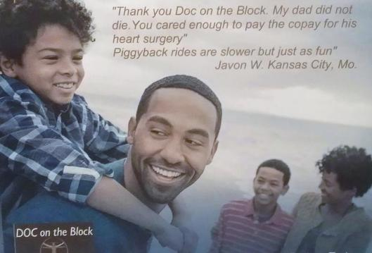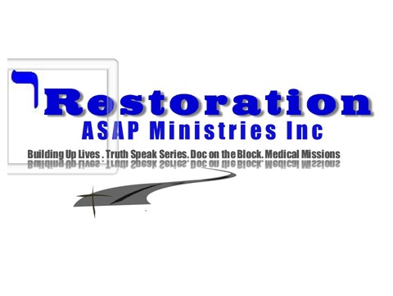

I wanted to keep you informed and up-to date with DOC on the Block. We are a part of the New Social Agency in St Louis, Mo and have a new partner willing to donate his time and skill to support this effort. Feel free to call 314-532-8820 and sign up to participate in the Co-Pay Program. The program was set in place to help with fees so you can keep your doctor’s appointments. Restoration ASAP Ministries Inc. is raising awareness and funds for what seems to be an ever growing concern within our communities.

Currently, as many as 32 million Americans are living without insurance coverage. The main reason; coverage is priced too high for the poor in states where Medicare was not extended. Restoration ASAP is a Social Agency that support those struggling to find treatment and services that will help their plight.

We are actively raising at least $50,000 to support the immediate need from the phone calls added to the waiting list. Our goal to maintain an outlet for referrals and support programs in our communities.

We know we can meet the need with your support. Would you please consider making a donation? Visit us online at www.restorationasapministriesinc.com to learn more and make a donation. You can also mail in a donation sending a check or money order. Please make them payable to Restoration ASAP Ministries Inc. PO Box 11045 St Louis, Mo 63135. We are a 501 c 3 Corporation and your donations are tax deductible.
Together we can do more for our families struggling to pay a co-pay in ordered to be seen by a doctor or dentist. Please donate $10.00 or your best gift.

Thank you in advance for your generosity.
Sincerely,

Diana Clark Gamble CEO Restoration ASAP Ministries Inc.

P.S. Speak to your family and share the information. Too many of our loved ones have died waiting for medical treatment simply because there were no funds the co-pay.

